**Sample Application Development**

* In this series, we will be developing some microservices to serve the supermarkets for the inventory and sales

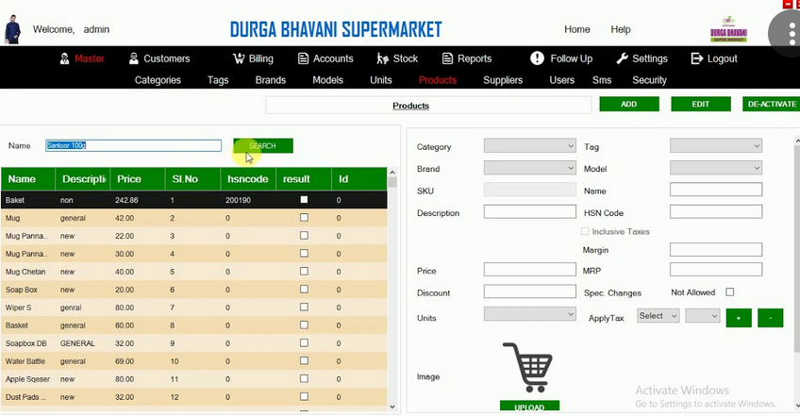

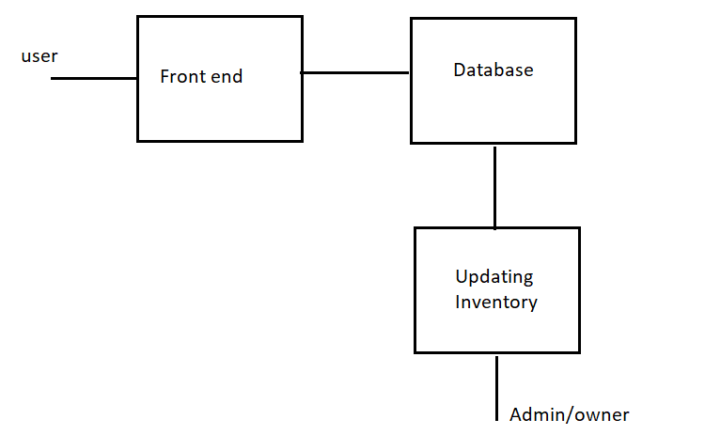

Here, Admin/Owner updates inventory, and those details are visible to front end user by Database.